Pre-course account transfer / account merging
Important: To successfully merge your pre-course account with your student account the steps have to be followed before you first login with your regular student account!
To merge your pre-course account with your regular student account, please proceed as follows:
- Go to https://studip.uni-goettingen.de
- Log in with your pre-course account. Usually it has the form p_firstname_lastname. The password should have been sent to your private email address when you registered for the pre-course.
- After login you will find a link “Studentische Nutzerkennung verwenden” at the right side of Stud.IP.
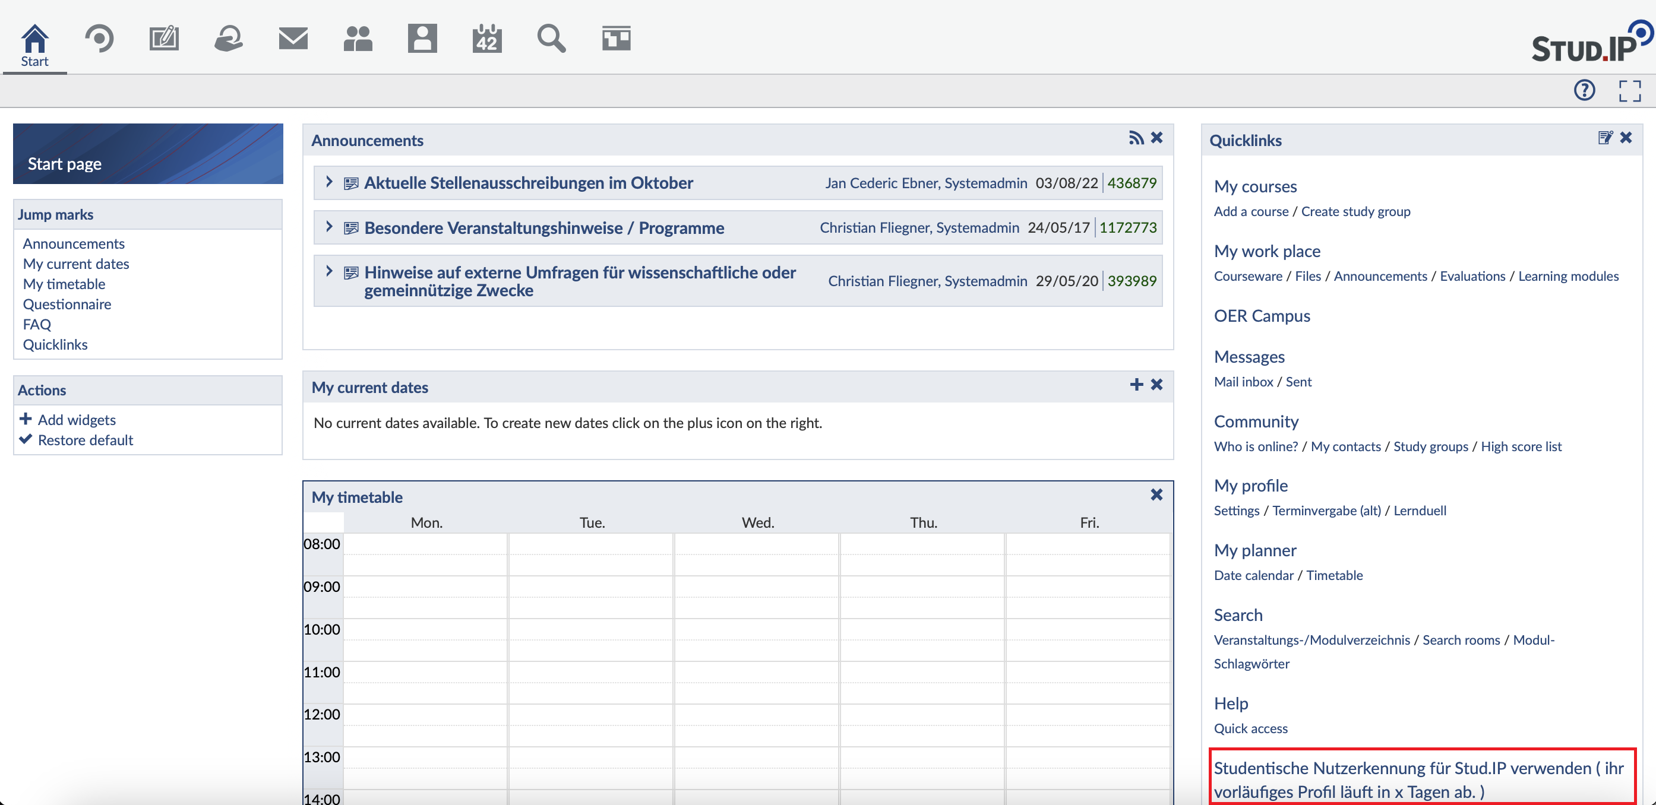
- After you click on it, enter your regular student username at “Nutzerkennung” and your student password at “Passwort”, both of which you received with your student ID
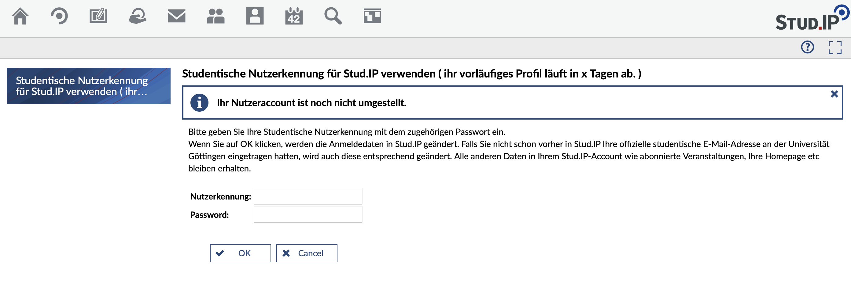
- Then log out
- Now you're only using one account. All data of the pre-course account has been transferred to the regular account and you can use the eCampus portal at https://ecampus.uni-goettingen.de for all systems

