Your student ID
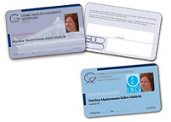
Every properly registered/enroled student at Göttingen University recieves a student ID, also known as 'chip card'. This chip card functions as a proof of identity, instrument of payment, semester rail ticket and library card.
You get your first student ID at the chip card issuing point from our advisors in the main lecture hall building. There you can also renew your semester rail ticket. If you need a second student ID (if your first card is lost or stolen), you can get it at the Office of Student Affairs, NOT at the chip card issuing point!
Here you can find all the information you need about your student ID:
erstellt von | Helena Zimpel
erstellt am | 10.03.2011 17:46

