Blogs at Göttingen University
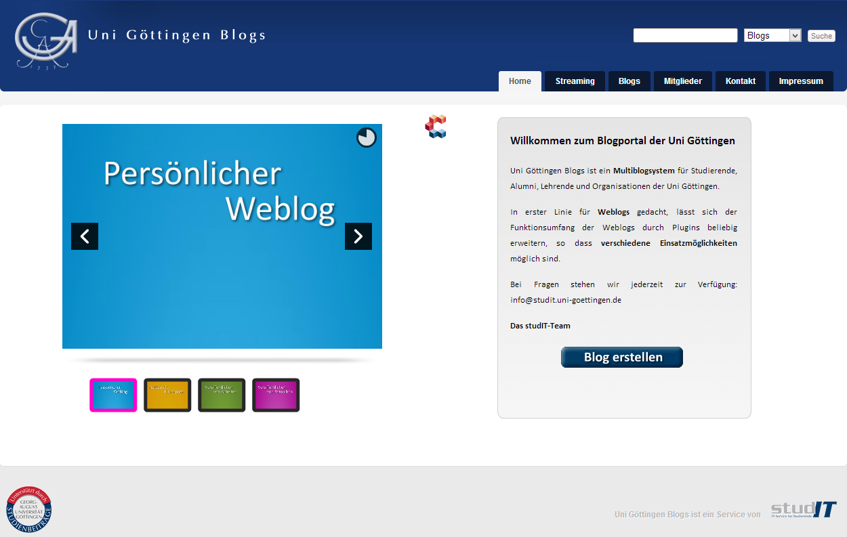
Blogs at Göttingen University is a multi-blog system for students, alumnis, lectors and organisations at Göttingen University.
http://blog.stud.uni-goettingen.de/
The range of functions is not only restricted to create web logs, for what this platform has been created for in the first place. It can also be extended as desired by using plugins which leads to different fields of application.

Contact
You can contact us anytime at info@studit.uni-goettingen.de or by using the form below.
tag> studIT blog university

