Upload your own profile picture
If you decide to use the standard theme you will be able to upload an own profile picture.
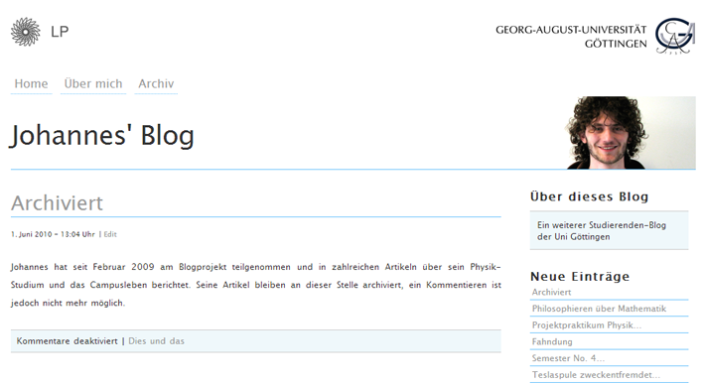

step 1:
Login at the administration page of the blog: http://blog.stud.uni-goettingen.de/deinblogname/wp-admin.

step 2:
At the menu item “Headers”, click on “Add New File”.

step 3:
Click on “Datei auswählen”, choose the photo you would like to use and confirm by clicking on “Upload”.

step 4:
Switch to the menu item “Settings” and choose the uploaded photo.
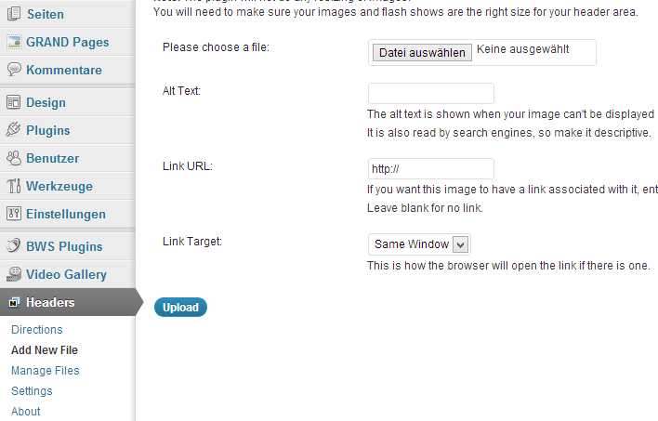

Please note:
To be displayed correctly, the photo should have the size 260×120. You can download a template here. Positioning the background-transparent profile picture in the middle of the template creates a very nice effect. If you have any problems while editing your profile picture, you can also send the image to info@studit.uni-goettingen.de for editing. We will try to respond to these kinds of requests as quick as possible.

