Set up of the Facebook comment feature

step 1:
First activate the plugin called “Facebook Comments”.
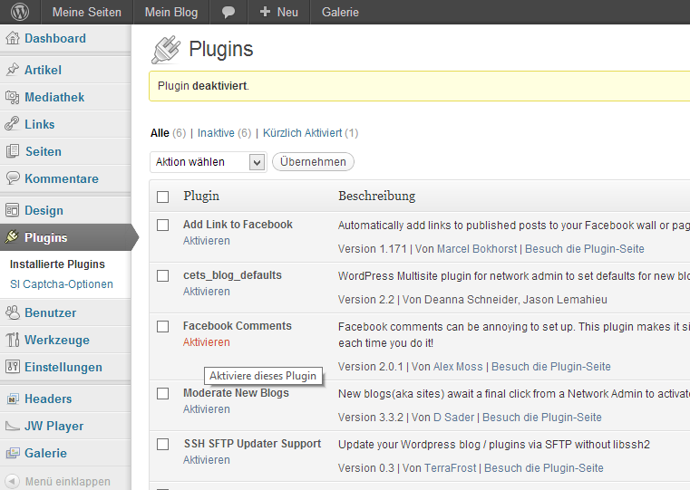

step 2:
Go to https://developers.facebook.com/apps and click on „Neue App erstellen“ (“create new app”).
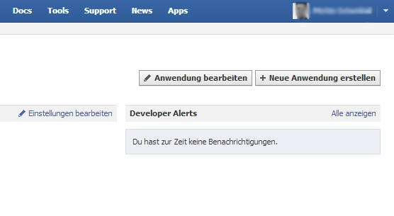

step 3:
Enter a name for the app, e. g. „Blog“, into the field called „Anwendungsname“ (“name”) and click on “Weiter” (“next”).
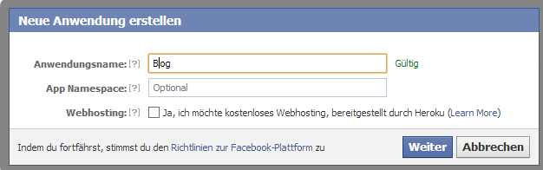

step 4:
Write down the App ID and click on “Änderungen speichern” (“save”).
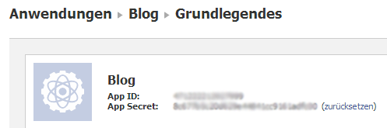

step 5:
At the administration interface of the blog, click on the menu item “Facebook Comments” and insert the app ID. Then, click on “Änderungen übernehmen” (“save changes”).


