Plugins (selection)

Dynamic Headers
By using dynamic headers it is possible to publish different headers for each page (for example a profile picture as shown in the example below). The only condition for this to work is that the theme must support this plugin. At the moment, only the standard theme supports it. By request, it is possible to integrate this feature into other themes.
To be displayed correctly, the photo should have the size 260×120. You can download a template here. Positioning the background-transparent profile picture in the middle of the template creates a very nice effect. If you have any problems while editing your profile picture, you can also send the image to info@studit.uni-goettingen.de for editing. We will try to respond to these kinds of requests as quick as possible.
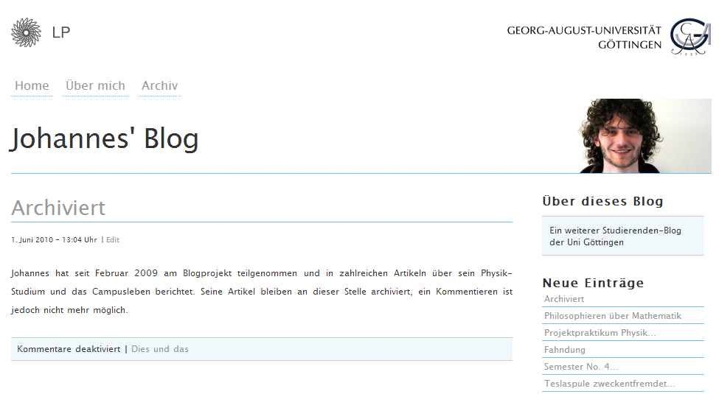

YouTube Embed Plugin
By using this plugin you can easily integrate YouTube videos into pages and articles by copying and pasting the video link at the respective position.
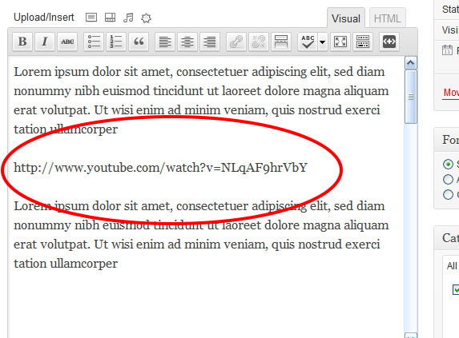

Statify
Statify is a plugin for statistics in compliance with data protection, which displays statistic data as number of visitors, referrers and target pages on the home page of the management interface (dashboard).
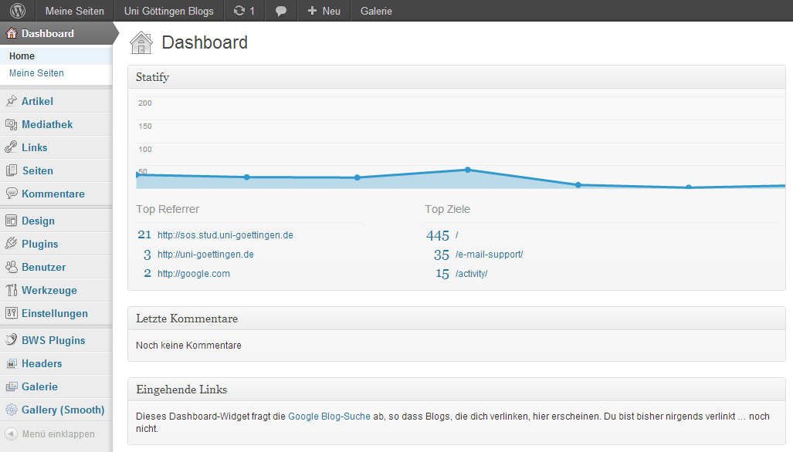

WPtouch
With WPtouch, WordPress offers an elegant solution to adapt to blogger's needs at the best when accessing web pages and using a mobile device. WPtouch supports iPhone, iPod touch as well as almost every other smartphone or tablet.

