Printing per upload of files (online print)
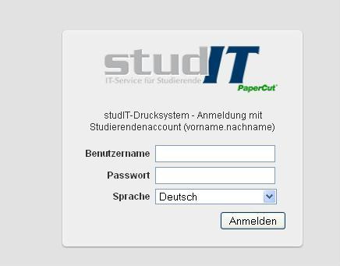
You have the chance to print documents of the type PDF and XPS without the installation of printer driver and client software. Hereto you have to login with your student account on the user website of the printing system:
http://print.student.uni-goettingen.de/
Under “Online-Druck(online print)“ you can upload accessible files in three easy steps, after you have clicked on “Druckauftrag absenden( send printing job)“ .
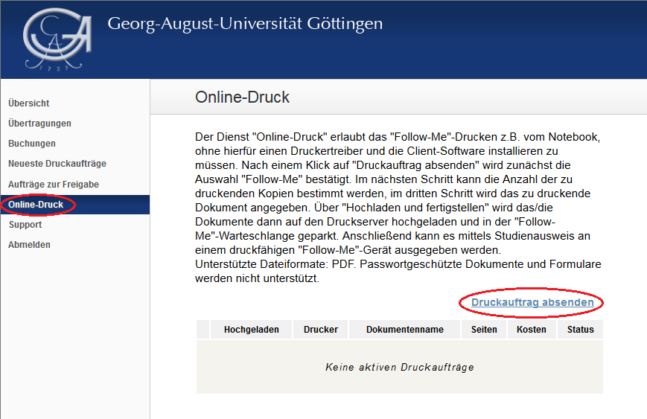

1. Confirm "Follow-Me"-queue
For the funciton “Online-Print” you can only output the prints through the "Follow-Me"-process . The lisiting is chosen by default and must only be confirmed:
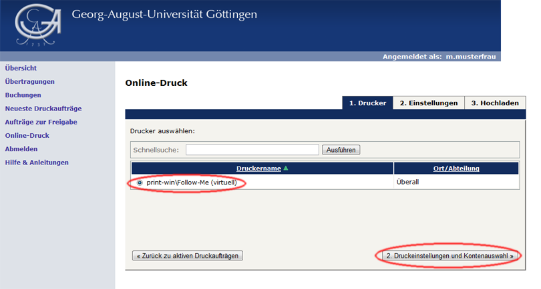

2. Determine the number of prints
In the next step you can increase the number prints. It is set on “1” by default:
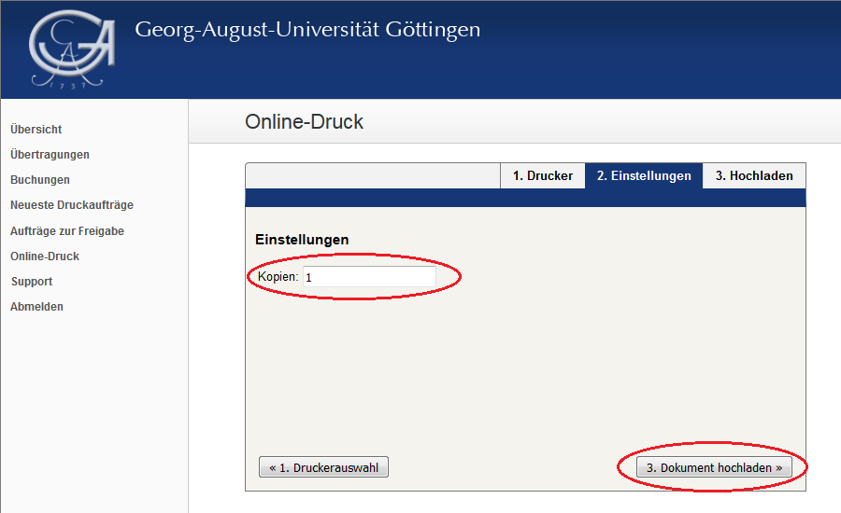

3. Choose file and upload it
In the last step you have to choose the file that should be printed. After a click on “Auswählen(Choose)…” a new window appears with which you can search for the file locally. After confirmation via “Hochladen und fertigstellen(Upload and finish)” the upload will start as well as the processing of the job.
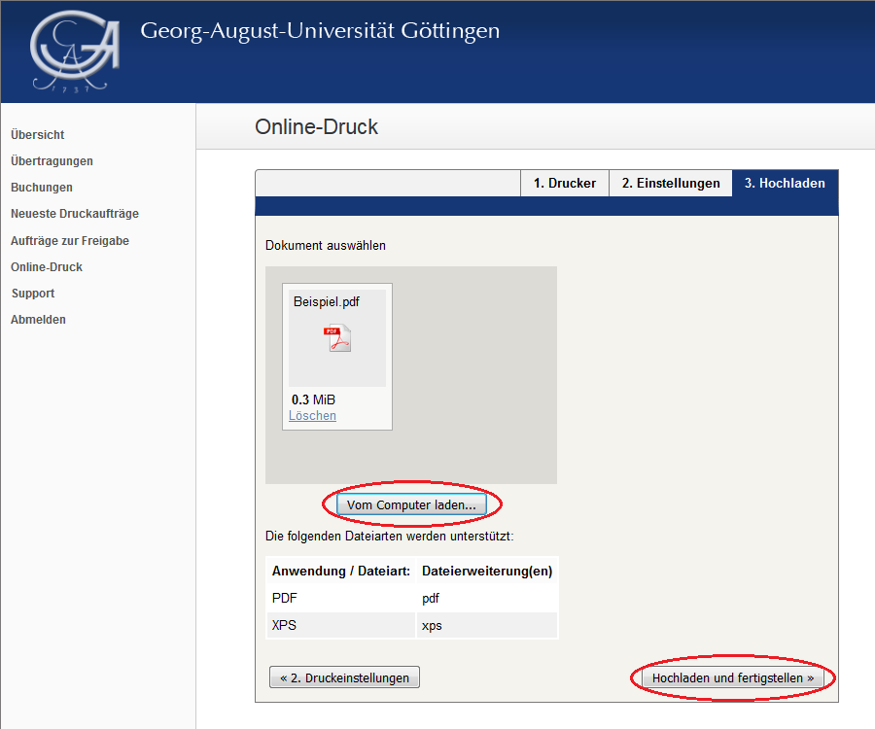

Check
The current processing status will be shown at the output side afterwards:
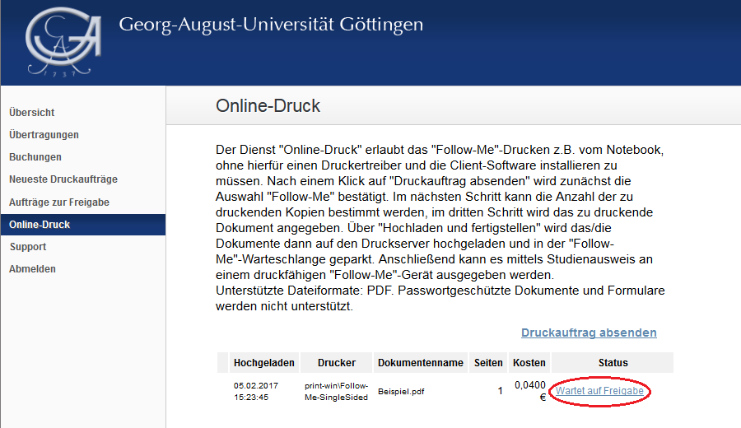
If the status changes to “Wartet auf Freigabe(Waiting for release)“ the process is finished.
Now, the job can be output via your student card using the [support:drucken:follow-me|Follow-Me-process]] .
Restrictions for the Online-Print:
You can only print files in the format PDF and XPS. Files that are password-protected cannot be processed. Furthermore, the printing is only possible through the "Follow-Me"-process .
This function cannot be used with iPhones and iPads, because this devices do not allow the upload of files per web form (Restriction in IOS).
tag> drucken pdf xps web-print online-druck
erstellt von | Sandra Klein
erstellt am | 07.03.2012 11:07

