Stud.IP in eCampus
Stud.IP can be used in eCampus. You do not have to log in to Stud.IP separately after logging in to eCampus. Stud.IP events have an effect on your Calendar in eCampus .

Note for first login
If you do not have a Stud.IP account yet, it will be created automatically. To confirm the Stud.IP terms of use, click on the link [I accept the terms of use].
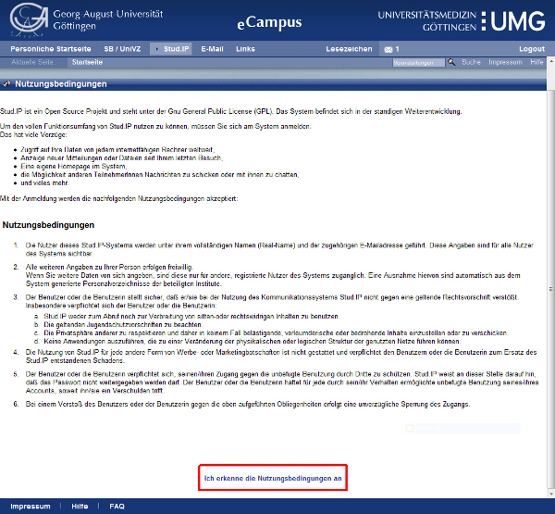

Information on how to use Stud.IP
You can find detailed documentation on Stud.IP here and here.

