Booking LSG Rooms

1. Booking in eCampus
Before you can use a room at the LSG, you need to book it. You do this ahead of time via eCampus. Log in with your Student ID. Should you not be able to log in, please contact studIT support! After booking a room, an electronic keycode can be written on your student ID card at the LSG.

2. Room booking basics
When logged into eCampus, click on the “LSG study rooms” tab.

Should you want to book a room now, click on “New room booking”:
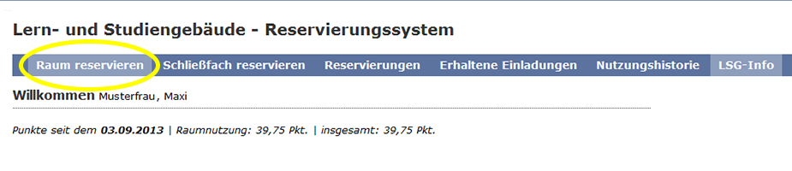
You can now chose date and time of your booking, as well as the type, size and equipment of the room. In the lower part of the page, you can always see whether rooms are still available for the specified time slot (green) or not (red).
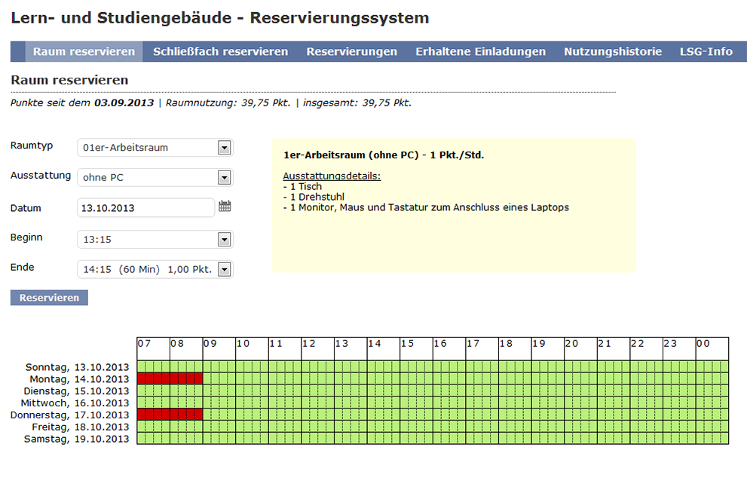
The page always displays what equipment comes with Multimedia PCs, for example:
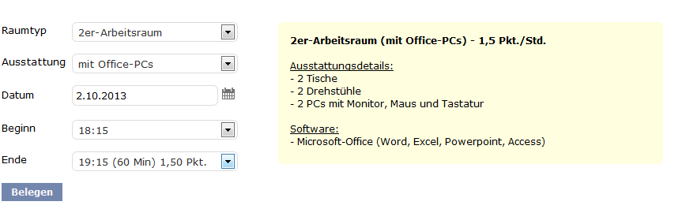
To finalize, click “book”.
Warning! When you click “book”, the room will immediately be reserved for you, you will not be asked to confirm your booking!

3. Booking points
Booking points are charged everytime you use a room in the LSG. You can access a detailed listing of how booking points are calculted here.
Simply put:
- The bigger the room, the more points you gather.
- The longer you use the room, the more points you have gather.
- The less points you have accumulated in the past, the further into the future you can book rooms. If you have gathered a lot of booking points (by regularly using the LSG), you will only be able to book rooms on short notice.
- The later a booking is cancelled, the less booking points are reimbursed.
- 40 days after you have used the room, occupancy points for this room are reset.
At all times, the LSG booking system in eCampus allows you to check how many points you have already accumulated and how many points will be charged for your current booking. Should you want to share a room with fellow students, you can share the points, aswell!

4. Sharing rooms - Sharing booking points
You can share the booking points for a room with other students. For example if you're sharing a room with your study group, only one of you needs to book a room as described above. After booking, you can ivite others via the booking overview:
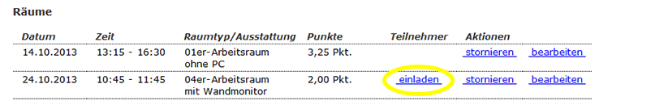
Clicking on the “invite” button will take you to the following selection screen:
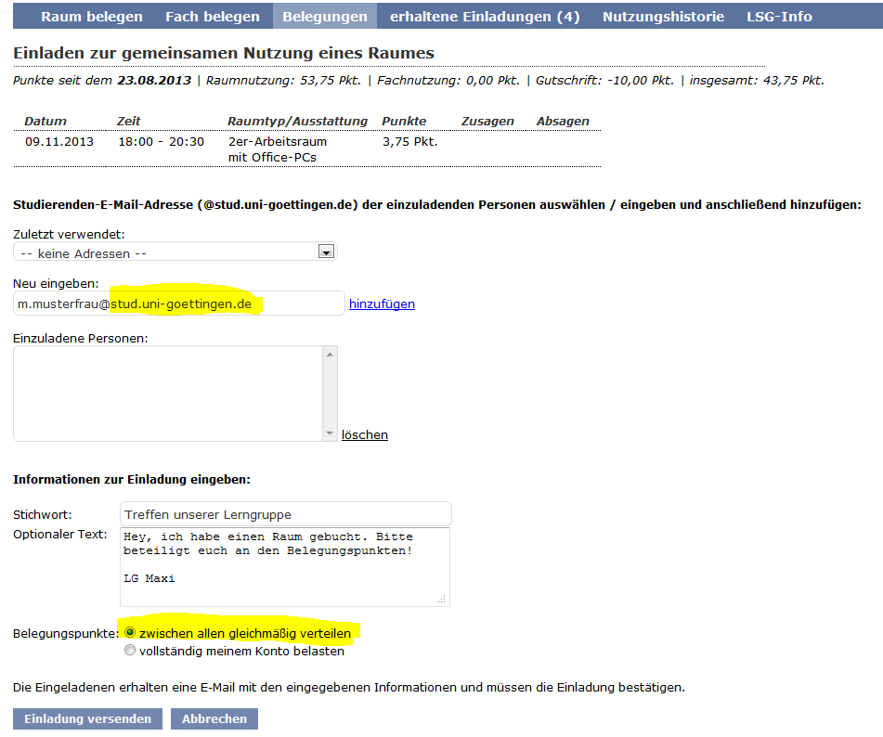
You can now enter the email addresses of your fellow students and add a message. You can either share the booking points equally or have them be deducted solely from your account.
Remember when booking: Only student email addresses work! (x.y.@stud.uni-goettingen.de) Other addresses (GMX, Gmail etc.) are not registered with the system.
As soon as you click “invite”, an invitation email is sent to the corresponding addresses. They then have to confirm the invitation (and, if need be, the point sharing) in the LSG booking system in eCampus.

5. Cancelling bookings
Should you no longer need your booking, you can cancel it, i.e. make the room available to other users. The earlier you cancel, the less points you get charged. If you cancel on short notice, up to 50% of the points may still be charged. Ýou can find an overview of the deadlines on this page.
You cancel bookings by accessing your booking overview (under the tab “bookings”) and clicking “cancel” behind the booking in question.

6. Editing bookings
Should you want to edit a booking (e.g. because the requirements of your study group have changed), you can change specific aspects of the booking.
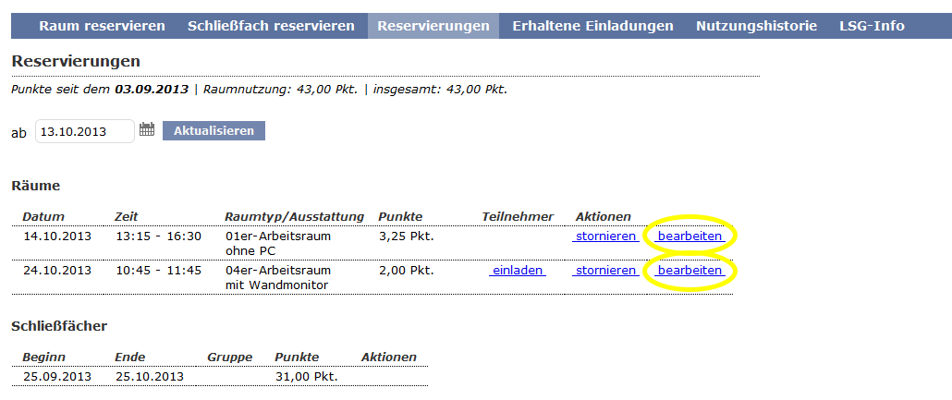
You then see a screen similar to the one when you made the original booking. You can now change the specifics of the room (excluding the date). Notice: Should you already have sent out any invitations for sharing a room, you can no longer edit the room size!
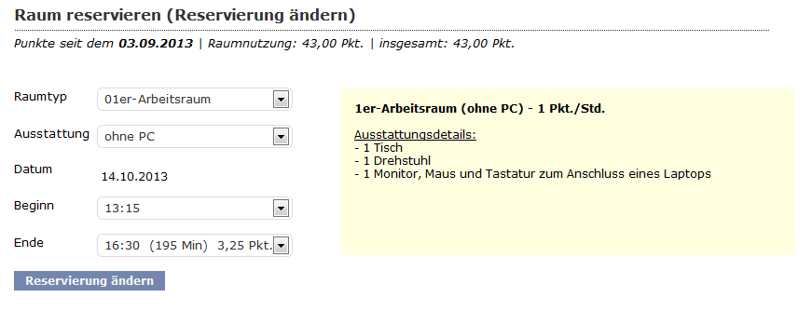
The points for the original booking will still be charged, if not more! Simply put: You can increase the point cost of your booking, but not decrease it.

