Computers in the libraries
Within a cooperation project of the SUB and studIT (part of the department IT of the university of Göttingen) new computers were purchased, which will be installed at the locations of the former so-called „Web-OPAC-computers“. Therefore, the operation of the devices changes. which now features a markedly additional value.
A crucial difference compared to the former use is the required login to the computer. At this we distinguish between two groups of users, which in each case are able to use different functions at the computer.

Students
Students can use the computers with all of their functions (Internet without restriction, printing, Office programmes, E-Mail Client, personal home directory). They have to log in by usage of the input screen with their student account after the computer has booted up. Students of Göttingen University get this account, consisting of userid and password, at the start of course together with their student ID since 2008. Students can pick up the account - if not existing - at studIT consulting locations (e.g. chip card issue point). Student users have to log out after the use of the computer to avoid abuse of their account.

University members, private persons & guests
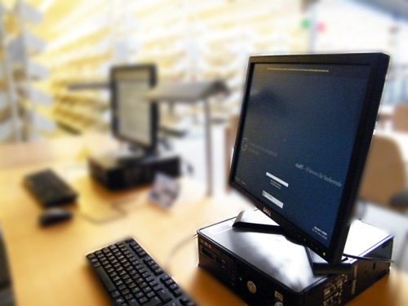
Every user of the library, who does not study at Göttingen University and therefore has no student account has the chance to get an anonymous guest-login, which is restricted to certain functions of the computer. Due to a lack of the printing account they are not able to print and can only use the website of the university of Göttingen and the SUB including the Göttinger Universitätskatalog (GUK)(university catalogue) as well as via HAN-Server the charged licenced online resources. All the other websites on the Internet are NOT AVAILABLE. This also applies to free databases and e-journals, which are offered via DBIS and EZB. The online offer which is not activated can alternatively be reached at the existing computers in front of the central information desk and the reading room counter respectively.
Like other students, every user using the „guest“ login can also use the new programmes that are installed on the new computers to edit documents. Furthermore, it is possible to use USB-sticks to save inquiries or documents. The chance of a virus attack of the computer through the USB-stick is very slender.
Every university member, private persons and guests should log out with their guest account after using the computer, so that the computer is free again for other students with extended functions.

Summary
Login for students: with student account
Login for university members, privat persons, guests: Click on the button „Gast-Zugang“ or type in „guest“ as a username, no password The logout of the computer takes place via the start menu, which is on the bottom left hand side of the screen or via the red button on the right hand side at the bottom of the screen.

In case of errors and problems
StudIT is basically responsible for the hardware of the computers (screen, keyboard, mouse, damage of the computer etc.). Please contact us via our contact form.
The same applies if students have difficulties using the computers, e.g.:
- difficulties with the login of students (login with student account)
- difficulties with printing
- difficulties with applications/programmes on the computer
We are within reach at:
telephone: (0551) 39-12345
E-mail contact form

Information concerning databases and electronic newspapers
At these computers students have access to the internet and every database and catalgoue. There are restrictions for guests!

Accessible databases for guests

Activated websites/ IP-addresses
- Every website of the university of Göttingen (134er IPs, also GUK with all parts of the site, Goe-Scholar etc.)
- every magazine with HAN-Link
- every GBV-catalogue
- EZB and DBIS*
- KVK; the appeal of the indidvidual OPACs is not possible
- ViFa Nord
- Subito
- BASE
- OAIster
- ZDB
- DFG
- Vascoda
- Webis
remark about EZB and DBIS:
- the full lists on the sites are callable
- DBIS: all databases with a green „D“ (accessible for free all over Germany („DFG-geförderte Nationallizenz“)), a yellow „U“ (in the network of the university of Göttingen) and a purple „C“ are callable via the HAN-Link and via the ug-subcd-Link (if CD-ROMs are used), respectively.)
- EZB: all yellow magazines are callable via the HAN-Link
- data bases and journals freely available in the web are not accessible (all IPs cannot be enabled)
tag>SUB DINO computers PCs OPAC catalogue data base bases e-journals electronic journal magazine guest guests anonymous login anonym

