Chip card issue point in the main lecture hall building (ZHG)
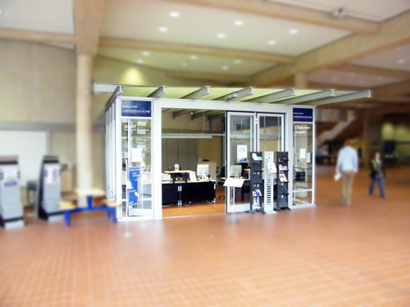
Location:
There, studIT provides the following services:
- first-time issuing of your student ID: Monday, Tuesday, Thursday and Friday 11 am - 12 pm
- renewing the student ID: Monday to Friday 10 am - 2:30 pm
You can find us between lecture halls 010 and 011 in the main lecture hall building.

